SLIDE: No. 1

Distinguished delegates, Ladies and Gentlemen.

It is my great honor and privilege to have this opportunity to describe our “Global University System (GUS)” project. My sincere gratitude goes to Professor Alfredo Soeiro for his kind invitation.

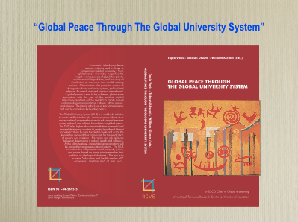

This slide shows the cover of our book “Global Peace Through The Global University System,” which has just now been published by the UNESCO Chair in Global eLearning at the University of Tampere, Finland under the auspices of the Finnish National Commission for UNESCO. The Editor-in-Chief is Professor Tapio Varis, UNESCO Chair holder, and co-editors are me and Professor William Klemm of Texas A&M. The book includes 35 contributed papers in about 500 pages and CD-ROM on the topic of Global University System (GUS) and eLearning/eHealthcare projects.

The purpose of this book is to make internationally known the philosophy, past and present actions, as well as future plans of the GUS, which have resulted from years of development and a seminal working conference at the University of Tampere in 1999. The aim of GUS is to attain global peace with the use of advanced Information and Communication Technologies (ICTs).

I recently learned that the Coimbra University in the next town south of here has the second longest history in the world. I hope this GUS will follow their precedence to last centuries and millenniums -- I have been working on this in the past three decades, which may correspond to the first step of a baby.

SLIDE: No. 2

Portugal was the first western country Japan dealt with almost a half millennium ago. We learned a lot from them -- we have many Portuguese-Japanese words, for example, “OBRIGATO” for “ARIGATO (not Arigator!!)” for “thank you,” etc.

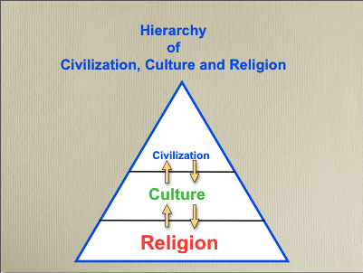

In 1549, St. Francisco de Xavier was sent to Japan by John III of Portugal to spread Christianity and gained many converts to the Roman Catholic Church, but, alas, after obtaining the technology of musket gun, Tokugawa Shogunate banned the spread of Christianity -- subsequently, Christian population in Japan is still only less than 1% even after a half millennium since Xavier’s introduction.

This is the first precedence of the Japanese technology transfer, i.e., cream-skimming civilization (the fruits of science and technology), but not importing culture nor religion. Although I admit that this is a provocative statement, this pattern is, I believe, the cause of the serious doldrums of current Japanese economy after bursting its bubble almost a dozen years ago.

SLIDE: No. 3

Vision of GUS

Economic interdependence among nations and cultures is spawning a global economy. Globalization also highlights clashes of divergent cultures and belief systems, both political and religious. If global peace is ever to be achieved, global-scale education, with the use of the modern digital telecommunications, will be needed to create mutual understanding among nations, cultures, ethnic groups, and religions. The Internet is the future of telecommunications and can be a medium for building peace.

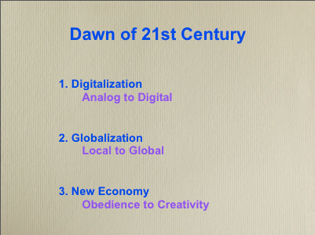

Circuit switching to packet switching -- “mind-change,” particularly of bureaucrats as Machiavelli once said almost a half millennium ago.

Raw material of industrial age was tangible, the raw material of knowledge age in the 21st century is IN-tangible.

Vicky’s case with Nobel prize.

Dr. Kaisa Kautto-Koivula of Nokia closes her paper in Part III with the words that “The biggest barrier for new development of Human-Centric Knowledge Society is our Industrial Age mindset!”

Creativity is the province of Homo sapiens. We live for future, not in the past. Science and technology open the future. However, the application of new technology often meets with “Creative Destruction” -- the famous words by Joseph Schumpeter.

Here needs good understanding of traditions and culture, and strong belief in scientific and moral principles.

SLIDE: No. 4

Mission of GUS:

GUS aims to build a higher level of humanity with mutual understanding across national and cultural boundaries for global peace.

The mission of GUS is to help higher institutions in remote/rural areas of developing countries to deploy broadband Internet in order for them to close the digital divide and act as the knowledge center of their region for the eradication of poverty and isolation.

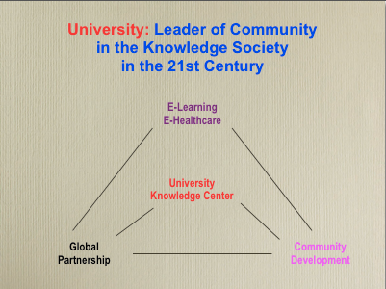
Goal of GUS:

The GUS is a world-wide initiative to create satellite/wireless telecommunications infrastructure and educational programs for access to educational resources across national and cultural boundaries for global peace.

Education and job skills are the keys in determining a nation's wealth and influence. The GUS education thus will promote world prosperity, justice, and peace, based on moral principles rather than political or ideological doctrines. The aim is to achieve "education for all", anywhere, anytime.

Activities of GUS:

GUS has group activities in the major regions of the globe in partnership with higher learning and healthcare institutions. They foster the establishment of GUS in their respective regions, with the use of an advanced global broadband Internet virtual private network. Those institutions affiliated with GUS become members of the GUS/UNESCO/UNITWIN Networking Chair Program located at the University of Tampere in Finland.

Students in these regions will be able to take their courses, via advanced broadband Internet, from member institutions around the world to receive a GUS degree.

These students and their professors from participating institutions will form a global forum for exchange of ideas and information and for conducting collaborative research and development.

SLIDE: No. 5

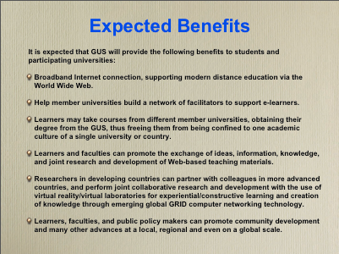

SLIDE: No. 6

We are very honored to have greetings by high-level dignitaries and representatives of international organizations in Part I of the book who endorsed the concept of GUS. Authors of these greetings gave their visions of how the university can advance the cause of world prosperity, justice, and peace. They are:

Read names of some of them.

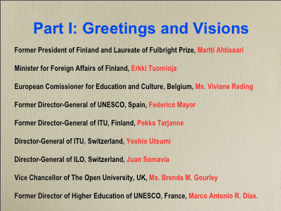
_______________________________________________________

Our paper "Creating Global University System" opens Part II, which emphasizes the important role of higher educational institutions not only as the knowledge centers of their community but also as the gateway to the world for collaboration of creating new knowledge in global knowledge society of the 21 st century.

The key to global peace, which is the ultimate aim of GUS education, can be attained by promoting mutual understanding and trust among the people of the world.

My schoolmate at Montana State University was Dr. Rafael Bozeman Rodriguez, Former President of Trinity College of Quezon City in the Philippines. He once told me a story of his uncle who was a chief of resistance during the Japanese occupation in the World War II (WW-II). One day he was caught and taken to the Japanese army camp. His family was deeply afraid and worried if he might be be-headed. In the middle of night, they heard loud voices at their house entrance. When they opened the door, they were totally astonished to find him with a captain of the Japanese military police. Both of them were completely drunk and singing joyously a school song of Yale University – they happened to be classmates.

The father of my wife, Hisae, was born in Montreal, Canada. When he went back to Tokyo, he studied at a French-speaking high school. At the time when the WW-II ended, he was the president of "Malay Shimbun," a Japanese newspaper in Singapore. To his surprise, he happened to meet his old high school classmate there, who was stationed as the Commanding General of the British Army. They renewed their friendship once again. Since then her father received special favor from the general until he returned to Tokyo.

These real stories of saving life even in wartime tell us how important it is to have trustful friendship among the people of the world with mutual understanding in early age of their education as much as possible.

Other papers in Part II describe how the challenges of globalization in the 21st century are to be dealt with along intercultural studies and peace education with the use of advanced information and communication technologies (ICTs).

SLIDE: No. 7

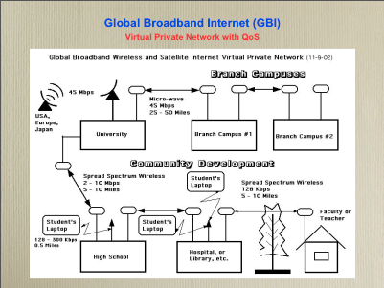

There are following 4 components here;

1. Satellite linkage:

GUS will be based on regional satellite hubs, typically located at a major university, that connect via high-speed satellite (~ 45 Mbps) to educational resource cities in the E.U., U.S., and Japan. In a sense, the regional satellite hub is to be the major Internet Service Provider (ISP) for not-for-profit organizations in the region, and the gateway to the outside world.

2. Microwave linkage:

Regional hubs link to branch campuses or other regional educational institutions via micro-wave (~ 45 Mbps) over relatively short distances (25-50 miles).

3. Community Development Network:

Communication from the hub and branch campuses to local sites, over distances up to 10 miles, is to be achieved by spread-spectrum wireless (~ 2-10 Mbps) Internet networks, which do not require licenses in most countries.

4. Wi-Fi connection:

The buildings with a broadband Internet connection will then also become relay points for the low-cost “Wi-Fi (wireless fidelity)” networks at 10 Mbps that are now rapidly appearing in Japan, USA and Europe.
____________________________________________

This advanced wireless communication with laptop computer will make e-learning possible for anyone, anywhere, and anytime with capabilities of Internet telephony, fax, voice mail, e-mail, Web access, videoconferencing, etc. This is not only to help local community development, but also to assure close cooperation among higher, middle and lower levels of education.

SLIDE: No. 8

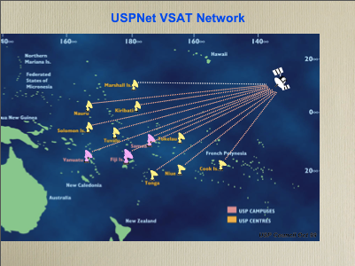

SLIDE: No. 9

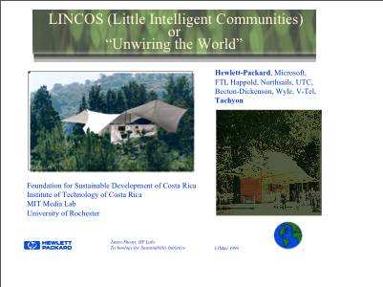

SLIDE: No. 10

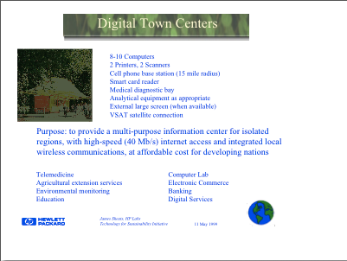

SLIDE: No. 11

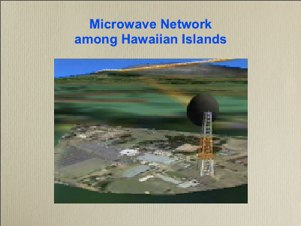

SLIDE: No. 12

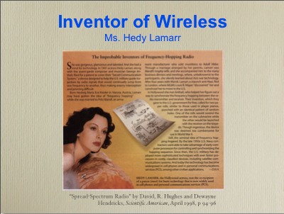

SLIDE: No. 13

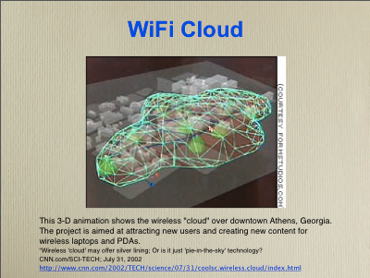

SLIDE: No. 14

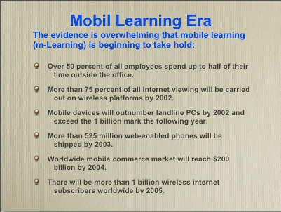

SLIDE: No. 15

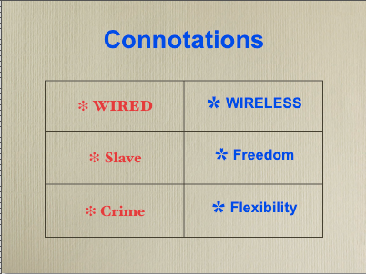

SLIDE: No. 16
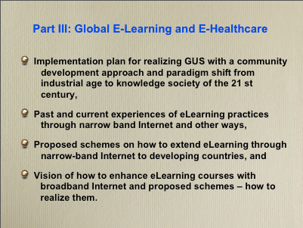
SLIDE: No. 17

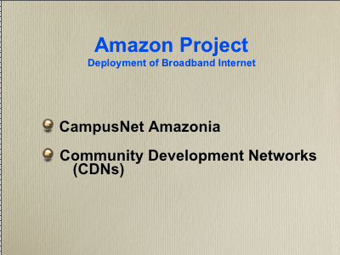

SLIDE: No. 18

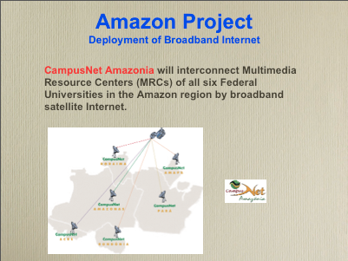

SLIDE: No. 19

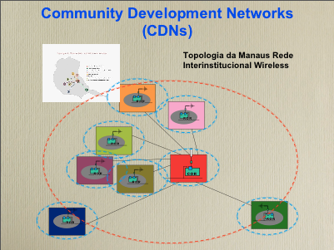
Community Development Networks (CDNs) will connect the universities with secondary and elementary schools, libraries, hospitals, local government offices and NGOs, etc., firstly in the City of Manaus and later in the cities of main campuses of the CampusNet affiliated universities, by broadband wireless Internet at drastically discounted rates or free of charge.

Similar projects are now starting in Cuba and the Caribbean region, Malawi and Uganda in Africa.

SLIDE: No. 20

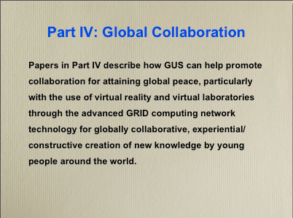

SLIDE: No. 21

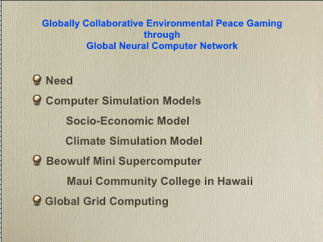

SLIDE: No. 22

Global Peace Gaming for Oil Crisis

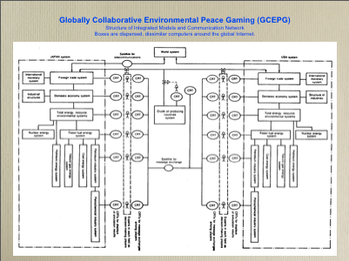

I once proposed a global peace gaming to cope with the oil crisis in early 1970s in response to Meadows’ “Limit to the Growth.” An outline of the hierarchical structure and distributed components of an integrated, interactive peace gaming/simulation system for energy, economics, and foreign trade in the USA and the Japanese sides was depicted in this diagram. Each block in the figure represented dissimilar computers in those countries interconnected through data telecom network (e.g., Internet nowadays). These computers included simulation models designated in each block. All models would be executed in concertedly via satellite and terrestrial telecommunication links.

SLIDE: No. 23

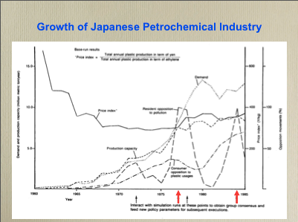

For example, suppose pollution in Japan exceeded a certain allowable level, say, around 1977 on this graph, the Japanese expert watching it on the display unit would stop the entire simulation. All participants, wherever they were located, would then try to find, with the use of the conferencing system, a consensus on a new set of pseudo-alternative policy parameters which would be executed until a new crisis appears, say, around 1984 on the figure. The process would be repeated for rational policy analysis, based on facts and figures, and with international cooperation of experts in both countries.

SLIDE: No. 24

We face a basic dilemma on the conduct of GCEPG Project. Namely, decision-makers must be concerned with the issues and matters of their constituents within the boundaries of regions, countries, municipalities, and counties for which they are elected and have their jurisdictions. Even though distributed simulation models we advocate may represent their concerns, they will be confined within their boundaries and borders. On the other hand, climate simulation cannot, by nature, regard the boundaries and borders, i.e., they have to be continuous phenomena. For example, dust storm from Sahara often causes trouble to Amazon rain forest or coral in the Caribbean sea; the other dust storm from Gobi desert causes respiratory disease in Korea and Japan; or forestry and fishery in Scandinavia are dying due to acid rain caused by industrial smoke from European countries, etc. Problems are now too intertwined to be well resolved in a system consisting of nation-states, in which citizens give their primary, and near exclusive, loyalty to their own nation-state, rather than to the largely global community.

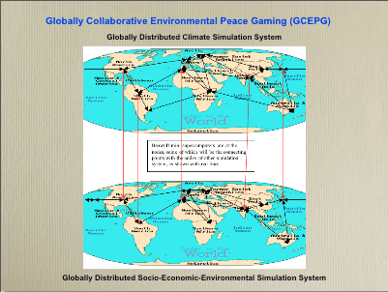

The best remedy and hope to cope with this modeling difficulties stemming on the basic difference between discrete, boundary-oriented socio-economic-environmental simulation and continuous climate simulation would be to accomplish distributed computer simulation networks of both of them with dispersed mini supercomputers in parallel fashion and both networks to be interlinked at appropriate locations (red lines in this diagram). The network of dispersed mini supercomputers (each of them with socio-economic-environmental model of their localities) will work as a single simulation of global economy. In a similar fashion, another network of dispersed mini supercomputers (each of them with climate model of their region) will work as a single simulation of global climate. Both networks can be linked in such a way that global socio-economic-environmental simulation will work closely together with global climate simulation. The decision-making parameters can directly be fed into nearby mini supercomputers for its regional socio-economic-environmental simulation model, yet having effects on both global simulation networks. This will be a perfect democratic participatory of global simulation. This will then eliminate the need of such a giant Earth Simulator of Japan (US$350 million and 4 tennis courts size).

SLIDE: No. 25

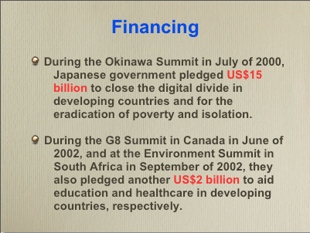

SLIDE: No. 26

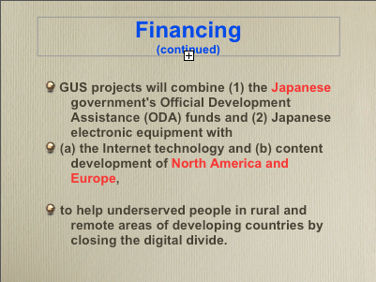

SLIDE: No. 27

Conclusion

The GUS program is a comprehensive and holistic approach to building smart communities in developing countries for e-learning and e-healthcare/telemedicine. Initiatives are underway to create the necessary infrastructure and educational liaisons, and some near-term educational access is expected. Early efforts have included international teleconference technology workshops that have tested the satellite/wireless technology that will be used in GUS.

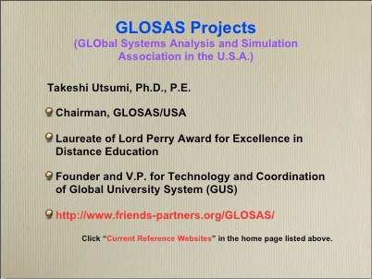

SLIDE: No. 28

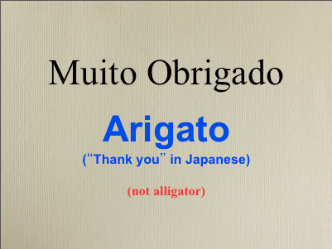

R

