TeleVital Assisted Telemedicine Network

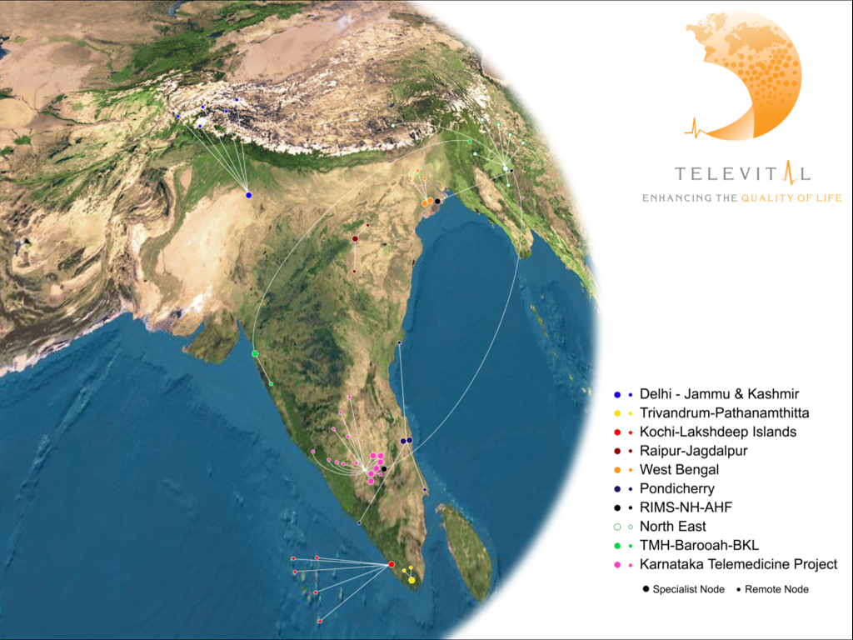

Our Focus:
Enhancing the Quality of Life – a paradigm aimed at reaching lives in over 150 countries and facilitating interactions that will power the healthcare system of tomorrow. We see a tomorrow where access and convergence of medical intellect will be reality and preventive medicine a way of life. Everyone has the right to a healthy life and we here to bridge the healthcare divide.

Our Vision:
“To Provide Integrated eSolutions for Comprehensive Health system Lifecycle Management”

Our Mission:
- To empower Health Systems with Integrated eHealth solutions that will enable them to provide quality healthcare that is affordable to the citizen and sustainable, thereby ‘Enhancing the Quality of Life”’.

- Enable and empower the poorest patient to avail quality health care any where in the world”.

- Empower medical service providers to monitor, diagnose, treat and manage patients by eliminating barriers of distance and time.

- To enable the best health care personnel to deliver care to the last suffering citizen with clinical reliability at sustainable costs.

Achievements:
TeleVital’s presence in the US and Indian market spans a period of over 3 years, and has implemented more than 100 Telemedicine projects. In India, TeleVital is the preferred Telemedicine technology solution provider to the Indian Space Research Organisation (ISRO) sponsored projects. With ISRO TeleVital has the unique experience of implementing more than 60 telemedicine turn-key projects across the Indian subcontinent. In the US, National Aeronautics and Space Administration (NASA) has been using our technology solutions for more than two years that has enabled us to be their program partner. The 2002 annual report of NASA features the success the TeleVital solutions.

TeleVital is founded by a team of distinguished technology veterans including: BV Jagadeesh, Kumar Malavalli, Storage Networking Guru, Mr. Ravi Amble, CEO of TeleVital, Prof Shivaram Malavalli, President of TeleVital and Kishore Kumar, CTO of TeleVital. The company has a strong medical advisory board with specialists of every clinical discipline. TeleVital has the privilege of having Dr. Jay Sanders, known as “The Father of Telemedicine” on its Board of Advisors. He is the founding member of the “American Telemedicine Association” and was its first President.

TeleVital assisted Telemedicine centers across India:

- Narayana Hrudayalaya – Bangalore – Specialist Node
- Rabindranath Tagore International Institute Of Cardiac Sciences, Kolkata - Specialist Node
- RIMS, Imphal – Specialist Node
- Civil Hospital, Naharlagun, Itanagar, Arunachal Pradesh – Remote Node
- Civil Hospital, Shillong, Meghalaya – Remote Node
Karnataka Statewide Telemedicine Project, 6 Specialty Hospital & 18 District Hospital: Operational Phase:-

- Narayana Hrudayalaya, Bangalore
- NIMHANS, Bangalore*
- St. Johns Hospital, Bangalore*
- Bowring Institute, Bangalore *
- Samatvam, Diabetic Centre, *
- JSS Hospital, Mysore
- District Hospital, Mandya
- District Hospital, Maddur
- District Hospital, Tumkut
- District Hospital, Shimoga*
- Taluk Hospital, Sagar
- District Hospital, Bagalkot
- District Hospital, Gadag*
- Taluk Hospital, Yadagir*
- District Hospital, Karwar
- Rotary Hospital, Sirsi
- Vishweshwaraiah Museum, Bangalore (Demonstration Unit)

Private Hospital Telemedicine Network

- Human Service Trust, GOPIO, Mauritius
- Family Physician Network, Karnataka
- Vikram Hospital, Mysore
- KLES Hospital, Belgaum
- KLES Hospital, Goa
- Divakar Speciality Hospital, Bangalore
- Bangalore Institute of Oncology, Bangalore
- Mangala Hospital, Hassan, Karnataka
- Bangalore Assisted Conception Centre, Bangalore
- Rotary Hospital, Sirsi
- Seventh Day Hospital, Tanjavur
- Seventh Day Hospital, Nuzvid
- Shirur Nursing Home, Bagalkot, Karnataka
- Ananth Ashram Hospital, Hosur
- Chaitra Clinic, KR Nagar, Karnataka
- eHealth Kiosk at HP i Community Project, Kuppam, AP, India.
- Teleradiology Solution at Supra Infoline, Bangalore

- Civil Hospital, Mokokchung, Nagaland - Remote Node
- Civil Hospital, Jorhat, Assam - Remote Node
- District Hospital, Mizoram* - Remote Node
- District Hospital, Tamenglong* - Remote Node

- Amrita Institute of Medical Sciences, Kochi - Specialist Node
- Indira Gandhi Hospital - Kavaratti- Remote Node
- District Hospital - Minicoy- Remote Node
- District Hospital -Amini - Remote Node
- District Hospital – Andrott - Remote Node
- District Hospital -Agatti - Remote Node

- R. R. Hospital, Delhi - Specialist Node
- Srinagar - Remote Node
- Leh - Remote Node
- Kargil - Remote Node
- Udhampur - Remote Node
- Partapur - Remote Node

- STNM Hospital – Gangtok - Remote Node

- JNM Hospital, Raipur, Chattisgarh - Specialist Node
- District Hospital, Jagdalpur - Remote Node
- District Hospital, Marwahi - Remote Node

- Tata Memorial Hospital, Mumbai - Specialist Node
- B. Barooah Cancer Centre, Guwahati - Remote Node
- BKL Walwaker Cancer Centre, Chiplun - Remote Node

- Ramakrishna Seva Prathistan Medical College, Kolkata - Specialist Node
- SSKM Hospital, Kolkata - Specialist Node
- District Hospital, Krishnagar- Remote Node
- District Hospital, Balurghat - Remote Node
- District Hospital – Malda - Remote Node
- General Hospital Pondicherry*- Specialist Node
- JIPMER Hospital - Specialist Node
- General Hospital, Karaikal* - Remote Node
- General Hospital, Mahe - Remote Node
- General Hospital, Yanam - Remote Node
- Trivandrum Medical College Hospital – Specialist Node
- District Hospital, Pathanamthitta - Remote Node

* Projects in progress

