2004 Fact finding Trip Report with the followings Individuals:

Date: from June 28 to July 7, 2004

Dr. Takeshi Utsumi New York
Chief Charles Ugo. Eke New Jersey
Mr.Ola Popoola, NITDA Nigeria

The following Universities were visited:

1. University of Jos,
2. University of Ife (OAU),
3. Federal University of Technology, Owerri (FUTO),
4. Abia State University Teaching Hospital,
5. River State University of Science and Technology

The team visited University of Jos first and was received by Dr. Mrs Donna Oti and the faculty members.
Our trip also took us around the campus and the Computer Centre, it appears that Unijos campus has an elaborate Computer Network and was in process of installing fiber Optics. Both the main Campus and the extended Campus are networked, they also showed interest in hosting the workshop and provide all the necessary equipment to conduct the workshop.

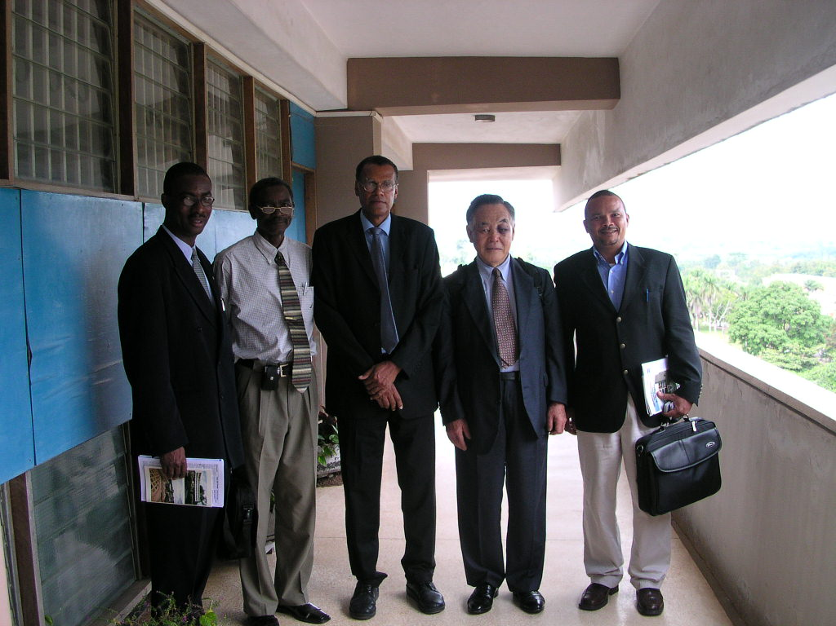
#2 OAU

We visited OAU and had meeting with the VC and Prof Kehinde and he showed us around and it was agreed that OAU will be the hub of GUS/Nigeria and Prof Kehinde will work with Mr. Popoola to draft the necessary documents including the concept document.
The first two Universities we visited have sufficient computer/Campus Network presence.

Federal University of Technology Owerri was in process designing Campus Network, there is LAN presence in some of the departments and also the Computer Centre located in the Campus.
The team visited River State University of Science and Technology and was welcomed by the VC, -- there was not much Campus Network presence.
Finally we visited Abia State University Teaching Hospital, and the arrangement to visit the school was made by Mr. Chris Uwaje, the crowd was unexpected and the interest was extraordinary, they have 6 VSATs and are very interested in Telemedicine and CME (Continue Medical Education).

Dr. Utsumi showed us the entire link to some document sample on his website.
The links are as follows:

Memorandum of Understanding (MoU) for Open Standards and Partnerships of Global University System
http://www.friends-partners.org/GLOSAS/Global_University/Global%20University%20System/Memo_of_Understanding/Cover_Sheet.html
or
http://makeashorterlink.com/?V2A225019

Constructions of the drafts of Nigerian version of the followings;
Protocol of GUS/Nigeria Consortium,
Reference: Protocol of Campus Net Amazonia Consortium
http://www.friends-partners.org/GLOSAS/Manaus Workshop/Tinker Foundation/Application Form/Tinker_Proposal_Web/Appendices/Appendix-III_Protocol/Protocol_of_CampusNet.htm
or
http://makeashorterlink.com/?N17264019

Global Peace Through The Global University System
Tapio Varis - Takeshi Utsumi - William Klemm (Eds.)
University of Tampere, Finland 2003
ISBN 951-44-5695-5
The entire contents of this book can be retrieved at;
http://www.friends-partners.org/GLOSAS/Global_University/Global University System/UNESCO_Chair_Book/Bk_outline-D13.html
or
http://makeashorterlink.com/?M2D252E09

Takeshi Utsumi, P. Tapio Varis, and W. R. Klemm
"Creating Global University System"
http://www.friends-partners.org/GLOSAS/Global_University/Global University System/UNESCO_Chair_Book/Manuscripts/Part_II_Intercultur/Utsumi Creating GUS/Creating_GUS/GUS_web/Creating GUS-D12.htm
or
http://makeashorterlink.com/?I2F231019

Offices Visited are as follows:

- Japan Embassy
- World bank
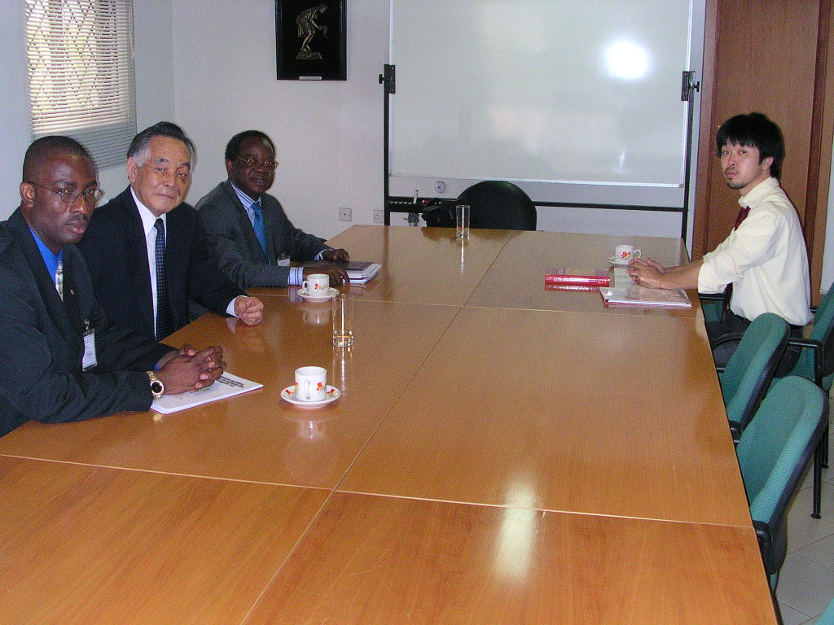
#1 Japan Embassy

Japan Embassy
After we concluded our visit to the Universities, we visited the Japan Embassy in Abuja to discuss the Grass Root Fund for the project and same time collected the appropriate form; the meeting was attended by Prof G.O Ajayi, Dr. Takeshi Utsumi, Chief Charles Eke and Mr. Ola Popoola with Mr. Yoshihiro Mizutani, First Secretary (Economic Cooperation) of Embassy of Japan. The form will be prepared and submitted back to the Embassy. Mr. Mizutani advised us to work towards K-12 for which the fund is deigned for. He further informed us that Japan is already involved in the educational development in Nigeria. Also he advised that the earlier we submit the form would be the better, because the form must go to the capital of Japan after he has screen it here in Abuja for approval and the process takes long.

Grass Root Fund of the Japanese Government
Comparison of Application Forms (Cuba, Brazil, Nigeria and Pakistan)
http://www.friends-partners.org/GLOSAS/Grass_Root_Fund/Comparison_of_Form.html

Reference:
Application for Grass Root Fund for the Manaus Community Development Network
http://www.friends-partners.org/GLOSAS/Manaus Workshop/Grass_Root_Fund/Application_Form/Appl_for_GRF_7-18-02.html
or
http://makeashorterlink.com/?L3C223019

World Bank
The Country Office Director has not arrived as at the time we visited the Nigeria Country Office of the World Bank. The return visit was entrusted in the hands of Mr. Popoola of NITDA – hopefully with Prof. Ajayi and Prof. Kehinde.

Japan Social Development Fund (JSDF) of the World Bank
http://www.worldbank.org/rmc/jsdf/approvals.htm

Reference:
Project Proposal (Draft: 12/27/03)
The Establishment of ICT-Center and Local Community Development Networks (LCDNs) for E-Learning and E-Healthcare in Ethiopia:
Application for Japan Social Development Fund (JSDF)/Seed Fund
http://www.friends-partners.org/GLOSAS/Global_University/Global%20University%20System/Africa/Ethiopia/Concept%20Paper_web/DraftProposal_281203.htm
or
http://makeashorterlink.com/?K2B221019

Outcome of Our Visit:

Nigerian Universities we visited showed extraordinary interest and willingness to cooperate in the formation of GUS-Nigeria.

As per Dr. Utsumi’s observations: “of many colleagues, we have already identified about a half dozen universities to become members of the GUS/Nigeria — some of them have already indicated their willingness to fill up the questionnaire form – see below”.

Finding in Nigeria:
1. During my fact-finding visit to Nigeria last June, I found out the followings;
(a) their universities are fairly well equipped with minimum access of web at 512 Kbps down/256 Kbps up satellite linkage to Europe, and local area network within their campuses.
(b) subsequently, most of their students use computers at their university.
(c) there are not many Internet access in their town, hence less access of Internet by students at their home; this is also because of high costs of purchasing computer and subscribing Internet.
(d) Therefore, their faculties’ desire is mostly receiving e-learning courses from developed countries, i.e., for them to enhance their course offerings.
2. Our strategy should then be;
(a) meet with their need first, i.e., importing e-learning courses from developing countries so that their faculties can enlarge their course offerings.
(b) by doing this, e-learning practice can be developed among them, i.e., firstly, for students of one university by its faculty within the university community, and later, extending the practice to students of other universities of other cities in Nigeria; for this domestic practice, basic e-learning tools, e.g, FORUM computer conferencing and WebCT, etc., would become necessity.
(c) for this latter phase, they need to have town-wide area network with broadband wireless Internet; for which deployment, we will seek fund firstly from the Grass Root Fund of the Japan Embassy and later from the Japan Social Development Fund (JSDF) of the World Bank.

Action Plan:

This questionnaire is just for match-making at this stage to locate appropriate parties in developed countries for Nigerians needs. Also, the filled forms will be attached to the JSDF application, just to indicate the real need from those universities in order to enhance the possibility of getting the fund.

DRAFT #3
(September 1, 2004)

Brief Questionnaires for Importing E-Learning Courses
from Developed Countries

(Please repeat this questionnaire for each desired course – up to three courses per university as for the initial pilot project. Pls feel free to expand the allocated spaces.)

Contact
Name of University | Name of university which administers e-learners who will receive the course from developed countries.
Name of Contact Person | This person could be the same as facilitator or mentor – see below.
Address | Title:  Department:  School:  Street:  City, Country, Zip:  Tel/Fax:  Email:  Web:
Subject
Title | Name of desired e-learning course to be imported from developed country.
Course content | Brief description of course content
Current status of the course | Describe briefly, if any has been conducted so far – particularly in e-learning mode with its delivery and administration.
Brief description of procedures | Describe briefly how this course is to be offered with hard copy course material, CD, web, and videoconferencing, list, email, and face-to-face meetings, in addition to libraries, databases, portals, etc.
Desired university | If you know, list one or two of the desired universities from which you wish to receive this course.

Learners
Level of targeted learners | Undergraduate or graduate (what year?), or life-long learner (adult), etc.
Estimated number of learners | How many in the first academic year, second, and third?

Infrastructure
Computers | Describe briefly about the availability of computers to learners;  1. desktop or laptop,  2. how many per learner at your school,  3. how they can access Internet at school or at home, etc.
Internet | Describe briefly about the current availability of Internet at school and/or learners’ home or work place;  1. what is the trunk-line speed of Internet from your school to the outside world,  2. how many such line does your school have,  3. how much per month the school has to pay for the line in the US$,  4. what is the speed of accessing Internet from learner’s computer,  5. how they can access Internet at their home, or working place, and how much they have to pay,  etc.
Procedures and Administration
Face-to-face meeting | Describe briefly how often face-to-face meetings are desired to be held with the instructor of this course at your university, e.g., once or twice a semester, etc. What will be the duration of the meetings, e.g., a few days or a week-long, etc.?
Course credit | Can your university accept the credit of the offering university?
Estimated tuition level | How much tuition can your e-learners pay for this course?

Support
Facilitator | Facilitator is to assist e-learners locally for their administrative and technical support in cooperation with your university’s staffs.  Provide name, full address, photo, and brief bio in the format similar to the ones at the end of the following paper;  Takeshi Utsumi, P. Tapio Varis, and W. R. Klemm  "Creating Global University System"  http://makeashorterlink.com/?I2F231019
Mentor | Mentor is to assist e-learners locally for their e-learning contents in cooperation with its instructors in developed countries.  Provide name, full address, photo, and brief bio in the format similar to the ones at the end of the following paper;  Takeshi Utsumi, P. Tapio Varis, and W. R. Klemm  "Creating Global University System"  http://makeashorterlink.com/?I2F231019

Subsequently, detailed procedures can be left out at this stage; which can be discussed by the course-offering instructors / faculty members and the course-receiving mentor / faculty members during the workshop which will be held by the seed fund ($50,000) of the JSDF. They will then be able to formulate detailed procedures for administration and procedures, etc., which are to be covered by the large JSDF fund (up to $2 to 3 million) for which full proposal is to be submitted within a year after receiving the seed fund.
This will be a pilot project, which is to be replicated later to other universities, say, the University of Jos, etc.

What’s Next:
Next workshop is to be held at one of GUS/Nigeria member universities.
The fund raising for this workshop is to be made by;

(a) JSDF’s seed fund (USD 50,000),
(b) Grass Root Fund about (USD 40,000),
(c) Other funding sources.

As soon as we confirm a fund, we will start organizing the workshop, which main objectives are;

(a) Formal establishment of GUS/Nigeria,
(b) Configuration of e-learning courses with the use of currently available Internet infrastructure,
(c) Configuration of joint projects among GUS/Nigeria member universities and with GUS member universities outside Nigeria,
(d) Formation of task force committees for deployment of broadband Internet for e-learning and e-healthcare in Nigeria,
(e) Construction of full proposal to the JSDF (up to USD 2 to 3 million) which is to be submitted to the World Bank within one year after receiving the seed found.

Others:

Visit following web site which include some photos;

a. Third Annual Digital Bridge Africa -- Global Partnership Conference on ICT and Development, Abuja, Nigeria -- June 23-26, 2004
b. Fact-finding and assessment trip to establish GUS/Nigeria -- June 27-July 8, 2004

http://www.friends-partners.org/GLOSAS/Global_University/Global%20University%20System/2004-06,%20Digital%20Bridge%20Africa/Digital_Bridge_Africa.html
or
http://makeashorterlink.com/?C37152E09

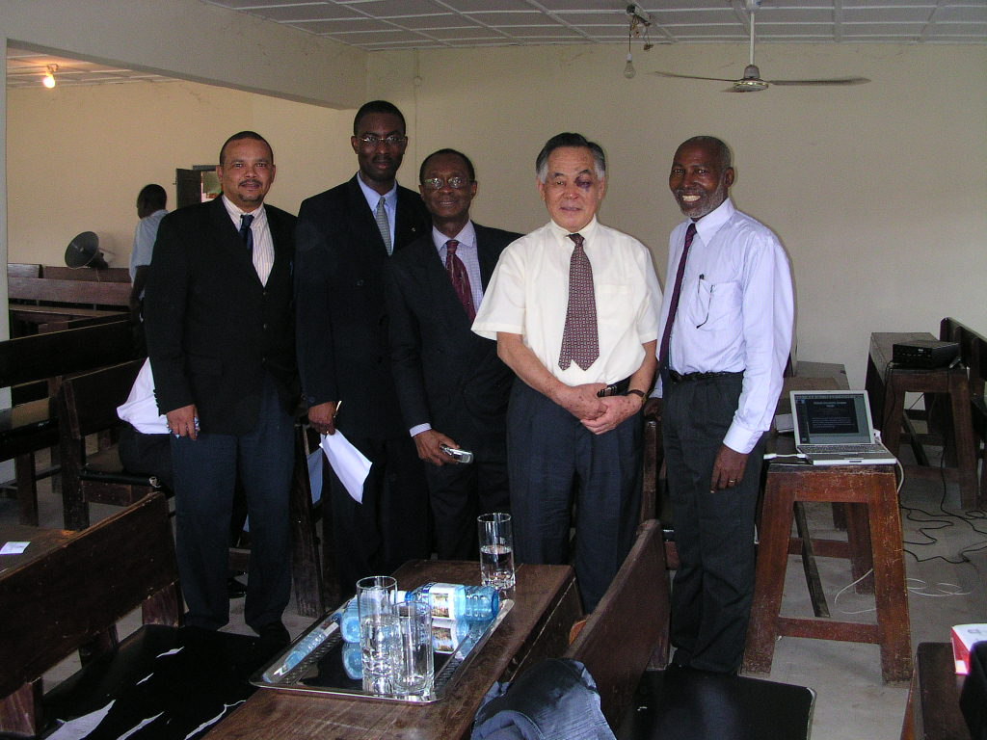
#3 Abia State University Teaching Hospital

The Followings are some minutes and report for the 2002 facts-finding trip.
ATTACHMENT #1 Minutes of Meeting in ABU Zaira
ATTACHMENT #2 Minutes of Meeting with Prof Jegede

Attachment #1

MINUTES OF MEETING HELD WITH CHIEF CHARLES UGO EKE, REPRESENTATIVE OF NIDO AT AHMADU BELLO UNIVERSITY, ZARIA, ON FRIDAY, 14TH JUNE, 2002.

ATTENDANCE:
Dr George Kwanashie, Deputy Vice Chancellor, ABU, Zaria
Chief Charles Ugo,
Dr John Dada, Programs Director, Fantsuam Foundation. Kafanchan
Mr Nasir Bello, Linkages Officer, Office of the Vice Chancellor, ABU, Zaria

INTRODUCTION:
Due to health concerns and logistic arrangement, this meeting initially scheduled for Thursday 13th June, was postponed to today at the behest of Chief Ugo Eke. He was welcomed by the Vice Chancellor, Professor Abdullahi Mahadi and given assurances of ABU’s interest and commitment to participating in the GUS project.

BRIEFING:
At a later session with the Deputy Vice Chancellor, Dr Kwanashie, Chief Ugo Eke was briefed on the various initiatives being undertaken by ABU for the Management Information System (MIS) of the university, setting up wireless Internet access for the university. Ahmadu Bello University is perhaps the only Nigerian university that has students-intake from all local governments in Nigeria. Its spread of student-intake extends to neighboring countries of Niger and Cameroon.

The DVC emphasized the need for a direct linkage of the GUS with the participating universities and institutions and a minimization of bureaucratic hurdles that may dampen enthusiasm or impede progress of the project.

The university has at the moment two cybercafes on the main campus, one café at the Institute for Agricultural Research and has plans for similar facilities for all the satellite campuses. The university also has plans to introduce degree and post-graduate degree programs in Management Information Systems.

ABU’s preferred approach to the GUS will be a focused and intensive effort to build capacities within the university to ensure adequate take-off and sustainability of the project. The complementary role of the NOUN in meeting the aspirations of many qualified university applicants is acknowledged, and ABU would like this complementarity to be enhanced through the GUS.

Dr John Dada also emphasized the positive role that can be played by rural-based NGOs like the Fantsuam Foundation and other rural – based educational and health institutions. Given the 70% rural habitation of Nigeria’s 120 Million people, GUS will do well to give adequate attention to extending the broadband wireless access to these rural-based institutions. Dr. Dada also pledged to ensure that adequate information about the GUS will be disseminated to other northern-based universities in Bauchi, Kano, Maiduguri, Sokoto, Minna to facilitate their full involvement. He has already made contacts with the University of Jos and will be taking Chief Ugo Eke to meet the ICT team there after this meeting in Zaria. Time constraints will not make it possible for Chief Ugo Eke to visit Kafanchan, the headquarters of the Fantsuam Foundation, but the organization’s interest and commitment to the GUS project was also noted.

The Deputy Vice Chancellor re-iterated ABU’s pleasure at hosting Chief Ugo Eke, and her willingness to host the first of Tak’s workshop in case if NOUN’s facilities are not available at the time. It was also suggested that the first GUS workshop should be held from 22nd – 25th August, 2002 in Abuja or ABU, Zaria.

The meetings ended at 1500 hrs and Chief Ugo Eke was presented a gift by the Vice Chancellor, Prof Abdullahi Mahadi. He was then taken by Dr. Dada to meet the team at the University of Jos.

At Jos, he was received by Dr John Nengel, the Chair of the University Computer Center.

Attachment #2 Meeting with Prof. Jegede

Dear Charles,
I apologise for the delay in sending this. I travelled soon after our meeting and nursed some serious malaria for about two weeks after that.

It was nice meeting with you during your recent visit to Nigeria and to see the enthusiasm with which you have taken the visit and all that it entailed. Like I said I am very prepared to work with all of you on the project as it has potential for lifting the ICT environment and technological literacy of Nigeria.

During our meeting (Charles Ugo, Olugbemiro Jegede and Joyce Wigwe) we touched on a number of issues summarised as follows:
1. We reaffirmed the need to make concerted effort at contributing to the technological advancement of Nigeria through ICT and the use of delivery technologies for all aspects of the country's development especially education.
2. We touched on the need to focus on the objectives of developing a robust proposal which could be used to source for external funds for technology development in Nigeria. We mentioned particularly the need to send such a proposal to the G8 secretariat amongst other sources to be identified.
3. We discussed the need to channel such proposal through one of the govt set-ups for endorsement as it will eventually be a govt to govt negotiation. I hinted that I had discussed this with the Honourable Minister of Education who welcomes the idea and supports that the proposal be developed and the NOUN to act as a focal point.
4. We appreciate the catalyst role that Dr Tak Utsumi is playing and suggested that he be invited to visit Nigeria for a stakeholders' workshop once the direction of the need is identified and the proposal is written. We suggested that Nigerians should be centrally placed to determine the exact needs of the country.
5. Your visit should be seen as a fact finding mission to which the experiences of others here in Nigeria such as NOUN, NIDTA, etc be added.
6. That the date for the proposal development in DC be fixed and a letter of invitation be sent to me ASAP as I will only be free either very early in July or later in August.

I hope the above has captured our discussion.

Bye for now and best wishes.

Olugbemiro Jegede

Report Written by Chief Charles Ugo. Eke and Dr. Takeshi Utsumi, Ph.D, P.E.
October 4, 2004

