Global University System
for
E-Learning and E-Healthcare

Takeshi Utsumi, Ph.D., P.E.
Founder and Vice President for Technology & Coordination of
Global University System (GUS)
Chairman of
GLObal Systems Analysis and Simulation Association in the U.S.A. (GLOSAS/USA)
43-23 Colden Street
Flushing, NY 11355-3998 U.S.A.
Tel: +1-718-939-0928
E-mail: utsumi@columbia.edu
Web: http://www.friends-partners.org/GLOSAS/

Abstract

The Global University System (GUS) is a worldwide initiative to create telecommunications infrastructure for access to educational resources across national and cultural boundaries for global peace. GUS aims to create a worldwide consortium of universities to provide the underdeveloped world with access to 21st Century education via Internet technologies.

The GUS works in the major regions of the globe with partnerships of higher education and healthcare institutions. Learners in these regions will be able to take their courses from member institutions around the world to receive a GUS degree. These learners and their professors from partner institutions will also form a global forum for exchange of ideas and information and for conducting collaborative research and development with emerging global GRID computer network technology. The aim is to achieve “education and healthcare for all,” anywhere, anytime and at any pace.

Background

Economic interdependence among nations and cultures is spawning a global economy. Globalisation also highlights clashes of divergent cultures and belief systems, both political and religious. If global peace is ever to be achieved, global-scale education, with the use of the modern digital telecommunications, will be needed to create mutual understanding among nations, cultures, ethnic groups, and religions. The Internet is the future of telecommunications and can be a medium for building peace.

Global University System (GUS) aims to build a higher level of humanity with mutual understanding across national and cultural boundaries for global peace. The mission of GUS is to help higher educational institutions in remote/rural areas of developing countries to deploy broadband Internet virtual private network in order to close the digital divide, and act as the knowledge center of their community for the eradication of poverty and isolation. The GUS education will promote world prosperity, justice, and peace, based on moral principles rather than political or ideological doctrines. Education and job skills are the keys in determining a nation’s wealth and influence.

GUS has a long history of concept development and testing of multiple hardware configurations suitable for remote Internet access. These initial steps are summarized in our recent book, Global Peace Through the Global University System, University of Tampere, Finland, 2003 (ISBN 951-44-5695-5). The purpose of this book is to make internationally known the philosophy, past and present actions, as well as future plans of the GUS, which have resulted from years of development and a seminal working conference at the University of Tampere in 1999.

The editors’ paper, ”Creating Global University System,” emphasizes the important role of higher educational institutions not only as the knowledge centers of their community but also as the gateway to the world for collaboration of creating new knowledge in global knowledge society of the 21st Century. This paper summarizes GUS accomplishments and shows that GUS is poised to begin implementation of Internet access and academic programs in remote areas of the world.

Goals

Modern e-learning and telemedicine require high-speed access to the World Wide Web. Multi-media requirements might include two-way audio, full-motion videoconferencing up to MPEG4 quality, television-quality netcasting, and high-resolution image transfer for telemedicine. The objective of increasing quality of audio/video delivery, high interactivity, and broadband throughput can be seen as a global objective of closing the digital divide to improve e-learning and e-healthcare services in order to eradicate poverty and isolation in rural/remote areas of developing countries.

As diagrammed in Figure 1, GUS programs and services will be delivered via regional satellite hubs, typically located at a major university, that connect via high-speed satellite (~ 45 Mbps) to educational resource cites in the E.U., U.S., and Japan. In a sense, the regional satellite hub is to be the major Internet Service Provider (ISP) for not-for-profit organizations in the region and the gateway to the outside world.

Figure 1
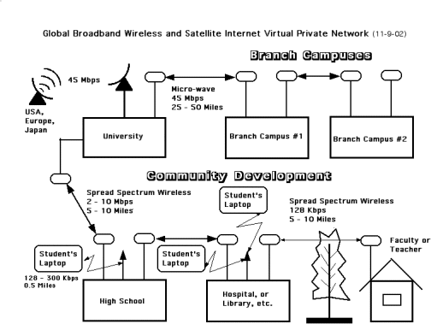

Regional hubs link to branch campuses or other regional educational institutions via micro-wave (~ 45 Mbps) over relatively short distances (25-50 miles). Communication from the hub and branch campuses to local sites, over distances up to 10 miles, is to be achieved by spread-spectrum wireless (~ 2-10 Mbps) Internet networks, which do not require licenses in most countries. The buildings with a broadband Internet connection will then also become relay points for the low-cost “Wi-Fi (wireless fidelity)” networks at 10 Mbps that are now rapidly appearing in Japan, USA and Europe. This advanced wireless communication with laptop computer will make e-learning possible for anyone, anywhere, and anytime with capabilities of Internet telephony, fax, voice mail, e-mail, Web access, videoconferencing, etc. This is not only to help local community development, but also to assure close cooperation among higher, middle and lower levels of education.

GUS is not limiting its efforts to university-level education. Some major U.S. universities are heavily involved in K-12 education as a means to assure quality in their student pipeline. The K-12 education in many underdeveloped nations is poor to non-existent, and they produce few students who are qualified to master a university education. The seeds of poverty and terrorism are sown in children through ignorance and propaganda. What could be a more important global problem to address? Leadership must come from the universities – including, hopefully, GUS.

Current Projects

The GUS Amazon Project will connect six federal universities in the Amazon region by broadband satellite Internet, and Community Development Networks. These will then connect the universities with secondary and elementary schools, libraries, hospitals, local government offices and NGOs, etc., by broadband wireless Internet at drastically discounted rates or free of charge. Similar projects are now starting in Cuba and the Caribbean region, Ethiopia, Malawi and Uganda in Africa, and have received inquiries for the same from Bangladesh and others.

Expected Benefits

It is expected that GUS will provide the following benefits to students and participating universities:

- Broadband Internet connection, supporting modern distance education via the World Wide Web
- Help member universities build a network of facilitators to support e-learners
- Learners may take courses from different member universities, obtaining their degree from the GUS, thus freeing them from being confined to one academic culture of a single university or country
- Learners and faculties can promote the exchange of ideas, information, knowledge, and joint research and development of Web-based teaching materials
- Researchers in developing countries can partner with colleagues in more advanced countries, and perform joint collaborative research and development with the use of virtual reality/virtual laboratories for experiential/constructive learning and creation of knowledge through the emerging global GRID computer networking technology
- Learners, faculties, and public policy makers can promote community development and many other advances at a local, regional and even on a global scale.

Organization

GUS is headquartered at the Global E-learning Center at the University of Tampere in Finland, under the direction of the UNESCO/UNITWIN Networking Chair, held by Dr. Tapio Varis. Currently, institutions with faculty members who are participating in GUS development projects include the University of Tampere, UK Open University, 6 federal universities of Amazonia, Havana Institute of Technology, University of Malawi, Uganda National Council for Science and Technology, McGill University in Canada, University of Tennessee in Knoxville, Cornell University, Texas A&M University, Maui Community College, University of Milan, University of Salerno, University of Twente, Catalunyan Open University, and many others. GUS will serve as an educational broker for universities, thus helping them gain international influence and access to students that they would otherwise not reach. Those institutions affiliated with GUS become members of the GUS/UNESCO/UNITWIN Networking Chair Program.

Financing GUS

During the Okinawa Summit in July 2000, the Japanese government pledged 15 billion US$ to close the digital divide in developing countries and for the eradication of poverty and isolation. During the G8 Summit in Canada in June of 2002, and at the Environment Summit in South Africa in September of 2002 they also pledged 2 billion US$ to aid education and healthcare in developing countries, respectively.

GUS projects will combine (1) the Japanese government's Official Development Assistance (ODA) funds and (2) Japanese electronic equipment with (a) the Internet technology and (b) content development of North America and Europe.

Conclusions

The GUS program is a comprehensive and holistic approach to building smart communities in developing countries for e-learning and e-healthcare/telemedicine. Initiatives are underway to create the necessary infrastructure and educational liaisons, and some near-term educational access is expected.

GUS is clearly an ambitious program, one that cannot be achieved by any one group, university, or national government. The program requires substantial collaborative contribution of ideas, expertise, technology resources, and funds from multiple sources. Those who value the vision of GUS are invited to join this great and noble enterprise.

References (All URL below were retrieved on November 8, 2004.)

Utsumi, T., Varis, T., and Klemm, W. R., Editors (2003). Creating Global University System, Global Peace Through The Global University System. Tampere, Finland: University of Tampere Press.
http://www.friends-partners.org/GLOSAS/Global_University/Global University System/UNESCO_Chair_Book/Manuscripts/Part_II_Intercultur/Utsumi Creating GUS/Creating_GUS/GUS_web_upload/Creating GUS-D11-053003.htm
or
http://makeashorterlink.com/?I2F231019
Varis, T., Utsumi, T., and Klemm, W. R. (Editors) (2003). Global Peace Through The Global University System, Tampere, Finland: University of Tampere Press, November.
http://www.friends-partners.org/GLOSAS/Global_University/Global University System/UNESCO_Chair_Book/Bk_outline-D13.html
or
http://makeashorterlink.com/?M2D252E09

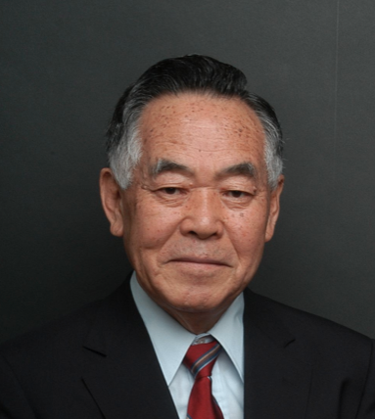
Dr Takeshi Utsumi is the Founder and Vice President for Technology & Coordination of GUS (Global University System) and the Chairman of the GLObal Systems Analysis and Simulation Association in the U.S.A. He is the 1994 Laureate of the Lord Perry Award for Excellence in Distance Education. His public services have included political work for deregulation of global telecommunications and the use of e-mail and voice over Internet Protocol (VoIP) through ARPANET, Telenet and Internet; helping extend American university courses to developing countries; the conduct of innovative distance teaching trials with "Global Lecture Hall" multipoint-to-multipoint multimedia interactive videoconferences using hybrid technologies; as well as lectures, consultation, and research in process control, management science, systems science and engineering at the University of Michigan, the University of Pennsylvania, M.I.T. and many other universities, governmental agencies, and large firms in Japan and other countries.

