Curriculum Vitae
Personal Details
Name: Dr. Ali Hamed Hussein El-Astal. 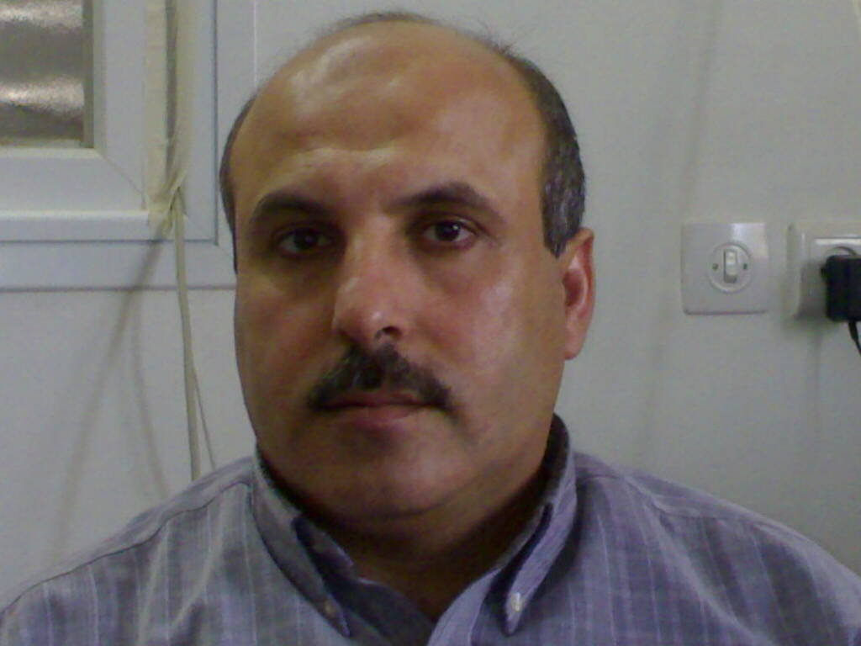

Home Address: 4/19 Al-Mohata Street, Khanyounis, Palestine.
Tel.+ 972 8 20 65074 Fax. + 972 8 2865309 Mobile: 059 378644

Work Address: Al-Aqsa University, P. O. Box 4051, Gaza, Palestine.
Tel. + 972 8 2826819, 826809 Fax. + 972 8 2865309

Martial Status: Married (Four children, 20/5/93, 12/1/95, 4/12/98, 12/12/2001).
Date & Place of Birth: 18 March 1964, Khanyounis, Palestine.
Nationality: Palestinian.

Study & Career Summary

1978-1981 Khanyounis Secondary School, Palestine, (≡ A Level), 90% Average, 1981.
1982-1986 Undergraduate Student, United Arab Emirates (UAE) University,
BSc degree in physics (major) and mathematics (minor),
Excellence (≡ First Class) July 1986.
1986-1990 Teacher of physics, Um Gafa School, Al Ain, Abu Dhabi, UAE.

1990-1991 MSc in Opto-Electronics and Optical Information Processing,
Department of Pure and Applied Physics, The Queen’s University of
Belfast, UK, October 1991.
1991-1995 * PhD in Physics titled: Spectroscopic Studies of YBCO Laser Ablation Plasma
Plumes, The Queen’s University of Belfast, UK, May 1995.
* MSc labs. Demonstrator, The Queen’s University of Belfast, UK.
1/6/1996-10/2001 Assistant professor in Physics, Al-Aqsa University, The Ministry of Higher
Education, P. O. Box 4051, Gaza, Palestine.
10/2001- up to now Associate professor in Physics, Al-Aqsa University, Gaza, Palestine.

1/10/1996- 10/8/98 Head of physics department, Al-Aqsa University, Gaza, Palestine.

1/11/1996- 1/3/97 & Consultant for Scientific and technological planning, the Ministry of Planning and

1/7/1997-1/11/97 International Cooperation, the Palestinian Authority, Gaza, Palestine.

1/12/1999- 1/9/2002 Head of science (physics, chemistry and biology) department, Al-Aqsa University.

1/9/2002- 31/8/2003 Assistant dean of scientific research, Al-Aqsa University.

1/9/2003-31/8/2004 Dean of Scientific Research, Al-Aqsa University.

1/9/2004-31/8/2006 Assistant to the University President, Al-Aqsa University.

1/9/2006-up to now Dean of Postgraduat Studies and Scientific Research, Al-Aqsa University.

